UNIT 4: HTML, Introduction to Hyperlinks, Hyperlinks - Examples Links to the same document

|  |  |
| --- | --- |
| 4.1 | INTRODUCTION |
| 4.2 | OBJECTIVES |
| 4.3 | HTML: AN OVERVIEW |
| 4.4 | INTRODUCTION TO HYPERLINKS |
| 4.5 | TYPES OF HYPERLINKS IN HTML |
| 4.6 | POINTS TO REMEMBER |
| 4.7 | GLOSSARY |
| 4.8 | CHECK YOUR PROGRESS |
| 4.9 | BIBLIOGRAPHY/ REFERENCES |
| 4.10 | SUGGESTED READINGS |

|  |  |
| --- | --- |
| ***4.1*** | ***INTRODUCTION*** |

Hyper Text Markup Language, also known as HTML, is a programming language that is used to build websites and web-based programmes. Let's examine Hypertext Markup Language and what web pages are for.

Hypertext: Text contained in other text is known as hypertext. The text is hypertext and has links. You click hypertext whenever you click a link that opens a new web page. A means of connecting two or more web pages is using hypertext (HTML documents).

A markup language is a type of computer language used to apply formatting and layout guidelines to text documents. Text becomes more interactive and dynamic thanks to markup languages. Text can be transformed into images, tables, links, and other things.

Web pages: A web browser typically translates content written in HTML into web pages. By typing in a web page's URL, you can locate it. A web page can be either dynamic or static. Static web pages can only be created using HTML.

As a result, HTML is a markup language used to design appealing web pages with styling that look fantastic in web browsers. A large number of HTML tags, each with a unique content, make up an HTML document.

The use of markup languages is pervasive in modern computing. You might not be aware of this, but word processing documents have various markup directives that describe the document's structure and frequently its presentation. This structural and expressive markup code resides behind and above ordinary word processing documents. The syntax for Web documents, however, is slightly clearer in both the standard Hypertext Markup Language (HTML) form and its XML-compliant alternative, XHTML. These markup languages are used to communicate the page structure to web browsers.

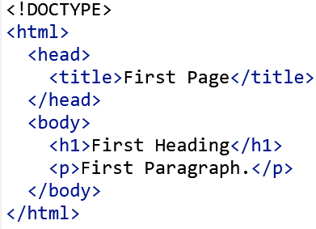Let's look at Figure-4.1 a simple HTML example.

Figure-4.1: A simple HTML structure

|  |  |
| --- | --- |
| ***4.2*** | ***OBJECTIVES*** |

After the successful completion of this unit, you will be able to-

* Understand the HTML
* Define the use of HTML hyperlink
* Explore Link to same document

|  |  |
| --- | --- |
| ***4.3*** | ***HTML: AN OVERVIEW*** |

Tim Berners-Lee, a scientist and CERN contractor, presented a system for CERN researchers in the late 1980s. He suggested an Internet-based hypertext system in a document he wrote in 1989.

Tim Berners-Lee is credited with creating HTML. Tim presented a paper titled "HTML Tags" in late 1991, and it became the first description of HTML that was publicly available. HTML5 is the most recent version of HTML. This tutorial will go into more detail later.

The structure of web pages is helped by the hypertext markup language (HTML), which is a standard markup language for displaying and reading content online via a browser. It has several tags because it is a markup language. For displaying text, tables, ordered lists, unordered lists, etc., there are tags available. A header section and a body section are the two primary portions of an HTML page. The body section contains all the tags required to generate the visible content of the web page, whereas the head region contains data that characterises the page, commonly known as metadata. Windows, Linux, and Macintosh are just a few examples of platforms on which HTML may be utilised.  
  
There are several HTML variations. HTML 5 is the most recent iteration. Advanced capabilities including canvas, web sockets, geolocation, native audio and video support, and more are included. HTML is often a simple language to learn and use. HTML files may be created by programmers using a basic text editor and run in a browser.

**Generation of HTML**

There have been several HTML iterations released since HTML's creation. The HTML version's quick introduction is provided below:

**HTML 1.0:** His 1.0, a basic release of the HTML language, was the original version of HTML.

**HTML 2.0:** The following version, which was introduced in 1995, was the one used as the standard language for website creation. Further capabilities including form-based file uploads, text boxes, radio buttons, and other form components can be supported by HTML 2.0.

**HTML 3.2:** The W3C published HTML 3.2 at the beginning of 1997. This version included more options for form components and could generate tables. Complex formulae on web sites can also be supported by it. It had become the accepted standard for all browsers by January 1997. Nowadays, virtually all browsers support it.

**HTML 4.01:** HTML 4.01, which was released in December 1999, is a relatively stable HTML version. It offers extra support for style sheets (CSS) and scripting capabilities for many multimedia components. This version is the current official standard.

**HTML5:** The most recent iteration of HTML is called HTML5. This version's initial draught was released in January 2008. Two significant organisations, W3C (World Wide Web Consortium) and WHATWG (Web Hypertext Application Technology Working Group), are now working on the HTML5 version.

**Benefits of HTML:**

* HTML is a commonly used markup language that aids in creating a website's structure that is simple to recall.
* HTML language is supported by all browsers.
* You can save huge files using the application caching function, and HTML is lightweight and quick to load.
* It comes pre-installed on every version of Windows; no further software is required.
* Vague syntax (but too flexible to conform to standards).
* Plain text may be modified in HTML with ease.
* It is simple to include other languages, such as JavaScript and CSS.
* HTML makes coding simple enough for even inexperienced programmers.
* HTML also permits the use of templates, which makes creating web pages simpler.
* Downloads are rapid since the text is compressed.
* Very handy for web design novices.
* All browsers, if not all, can support HTML.
* Almost all websitesif not allinclude HTML.

**Features of HTML:**

1) It's a really easy and straightforward language. Simple to comprehend and adapt.

2) Since HTML has so many formatting tags, generating presentations is a cinch.

3. As it's a markup language, you have the freedom to customise her website's content and layout as well.

4) Make it simpler for programmers to insert links into web pages (using HTML anchor his tags), enhancing users' desire in surfing.

It may be seen on any platform, including Windows, Linux, and Macintosh, making it platform neutral.

6) Assist programmers in enhancing her website with graphics, video, and sound to make it more appealing and engaging.

7) The case-sensitivity of HTML is zero. Hence, tags can be written in either lower- or uppercase.

**Basic HTML Tags:**

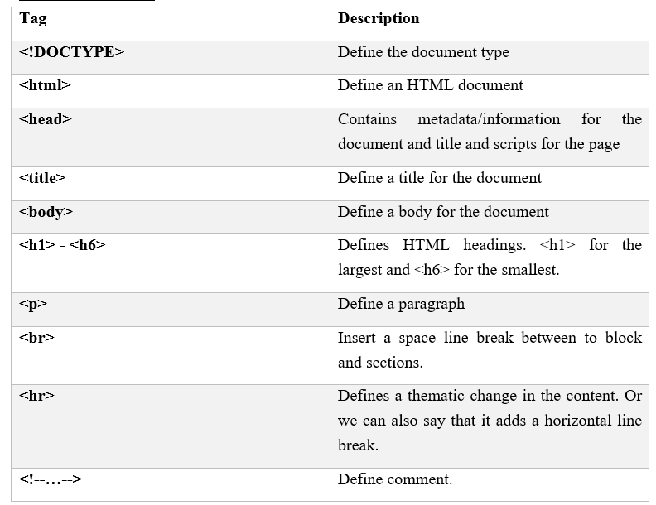

Table-1: Basic HTML tags

**HTML page structure:**

Here is a description of an HTML page's fundamental structure. It comprises the fundamental building blocks on which all web pages are constructed, including the doctype declaration, HTML, head, title, and body elements.

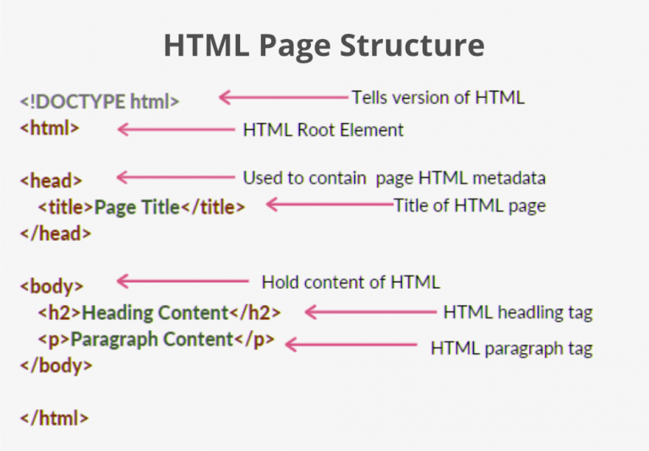Figure-4.2: HTML Page Structure  
Source: https://media.geeksforgeeks.org/wp-content/cdn-uploads/20220401160946/HTML-Basic-Format-768x534.png

**HTML DOM**

A programming interface for HTML (Hypertext Markup Language) and XML (Extensible Markup Language) documents is called the Document Object Model (DOM). explains how the text is accessed and updated as well as its logical structure.

In order to make it easier for programmers and users to browse through content, web pages can be displayed in an organised and hierarchical style using the DOM. With the Document object's commands or methods, you may quickly access and modify tags, ids, classes, attributes, or HTML components using the DOM. In order to access the HTML and CSS of a web page and give HTML components behaviour, JavaScript may also leverage the DOM. Hence, the Document Object Model may be thought of as an API for interacting and displaying HTML or XML documents.

Web pages are organised using HTML, and behaviour is added using JavaScript. Once the HTML file has been loaded in the browser, JavaScript is unable to interpret it directly. A related document is produced (DOM). The same HTML content is essentially represented by the DOM in a different way utilising objects. JavaScript merely translates the DOM. In other words, JavaScript is unable to comprehend HTML tags, but it can recognise h1 objects in the DOM. Now, JavaScript may use several functions to retrieve each object (h1, p, etc.).

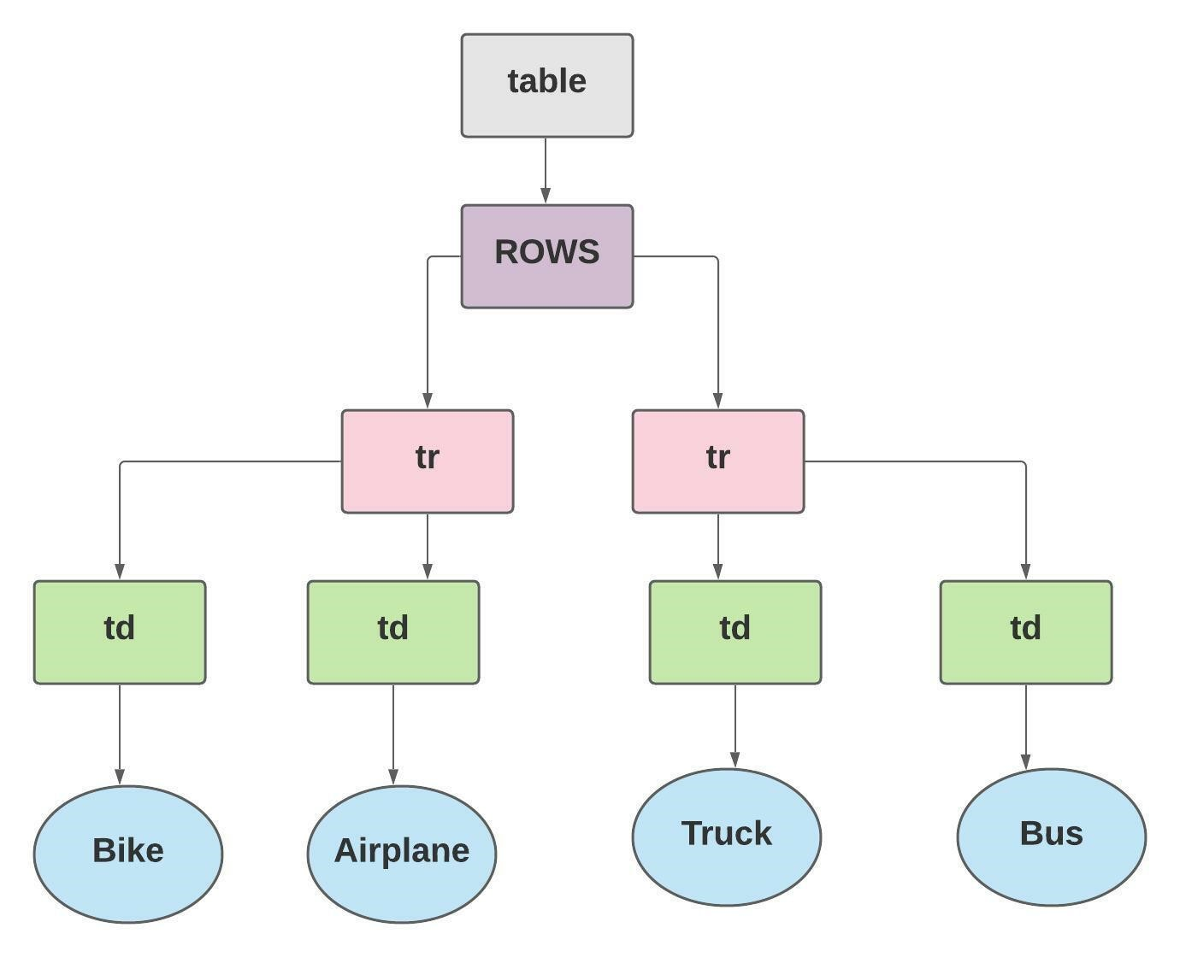Figure-4.3: HTML DOM example

|  |  |
| --- | --- |
| ***4.4*** | ***INTRODUCTION TO HYPERLINKS*** |

One of the most intriguing inventions the web has to offer is hyperlinks. They have been a component of the web ever since its inception, making it what it is today. You may link to particular sections of papers, link to other documents and resources, and make apps accessible at web addresses via hyperlinks. A link may be created from almost any piece of web material, and when you click or activate one, your web browser will direct you to another website (URL).

For instance, the main page of techalmirah.com has several articles as well as several links to the site's various parts (navigation features).

Figure-4.4: Website home page  
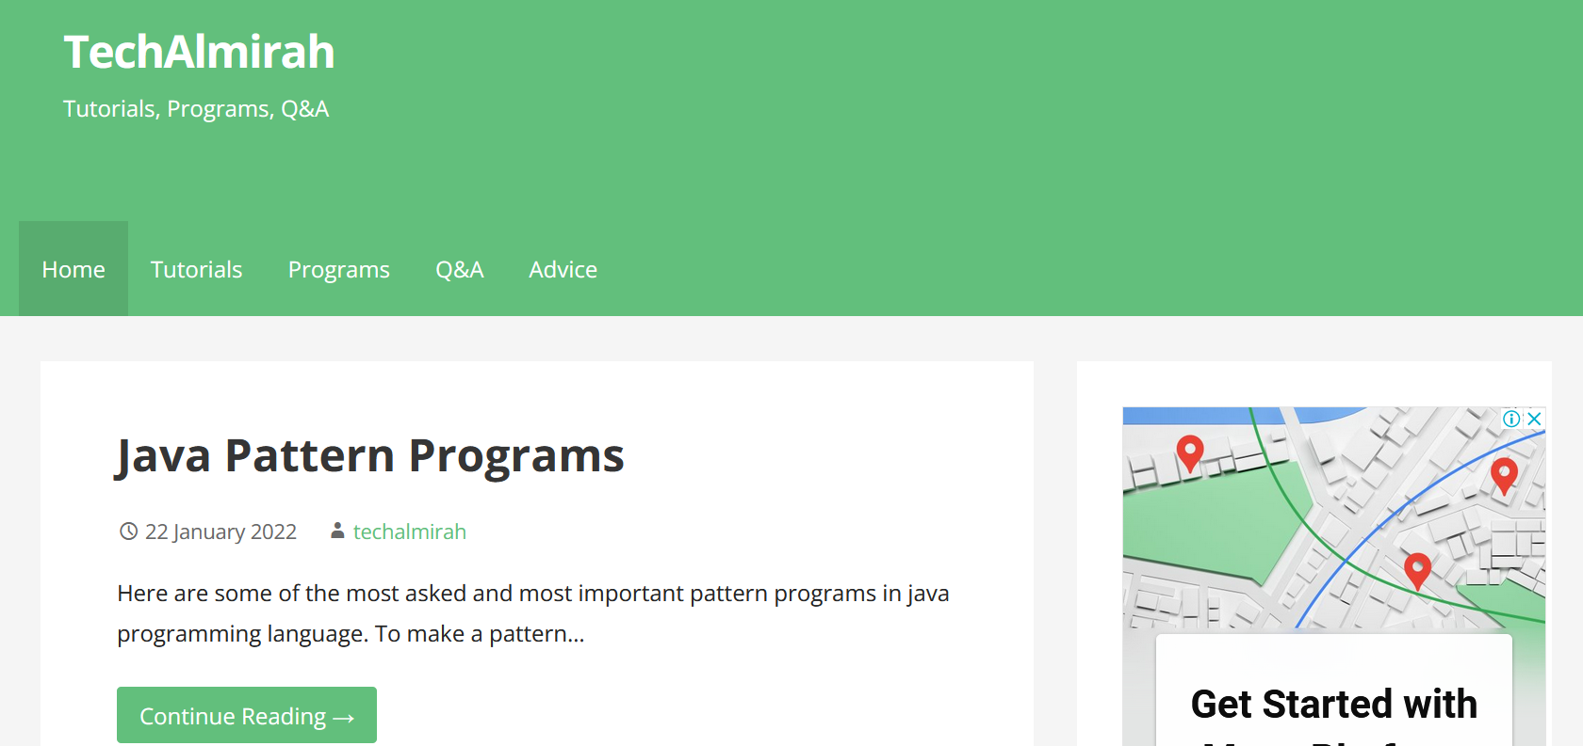**Source:** <https://techalmirah.com/>

This is a link that leads to another web page. An anchor and a direction are the two endpoints of a connection. An anchor that is the "target" anchor is the starting point of a connection. Any web resource, including an image, video, music file, software, HTML page, or HTML document element, can be considered here. Several websites and social networking sites (such as YouTube, Instagram, etc.) connect text or images to URLs. You are connecting your code to additional components that could or might not be present.

Hyperlinks are links in HTML. To get to another document, click on a link. The mouse arrow turns into a little hand when you hover the mouse pointer over a link.

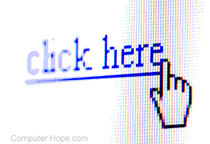Figure-4.5: Mouse pointer icon on Hyperlink

**Source:** <https://www.computerhope.com/jargon/h/hyperlink.png>

A hyperlink is defined by the HTML <a> element. Its syntax is as follows:

Figure-4.6: Hyperlink syntax

The href property, which denotes the location of the link, is the most significant attribute of the element. The portion that the reader can see is the link text. The reader is sent to the given URL location when they click on the link text.

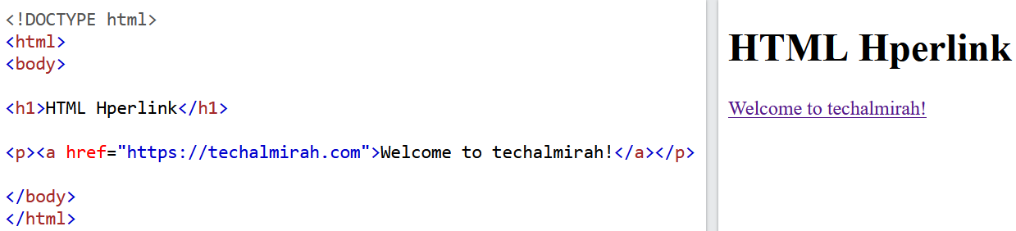**Example:**

Figure-4.7: A sample example of Hyperlink.

In all browsers, the link will appear as follows by default:

* Underlined, blue unvisited connections
* Underlined and purple links indicate visits.
* Red highlighted links are active links.

**Target Attribute:**

Linked sites open in the current browser tab by default. You must provide the link an alternative target in order to change this. Where to open the linked page is specified by the target attribute.

One of the following values may be present for the target attribute:

* _self is the default. Open document in selected window or tab;
* _blank for new window or tab;
* _parent for parent frame;
* _top for whole pane

**Absolute URLs vs. Relative URLs:**

The href property in the example above utilises absolute URLs (whole web addresses). Relative URLs (without the "https://www" portion) are used to specify local links, or connections to pages on the same website.

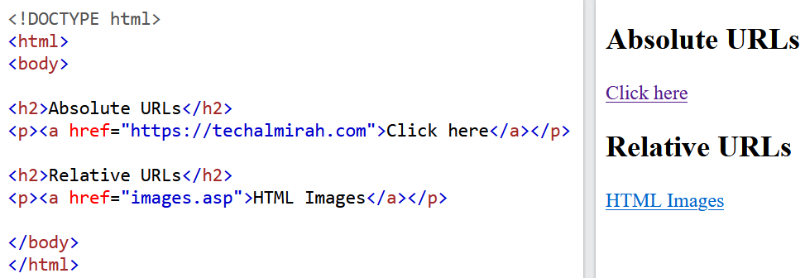Figure-4.8: A sample example of Absolute and Relative URLs

**Use an Image as a Link**

Use the <img> tag inside the <a> tag to utilise an image as a link:

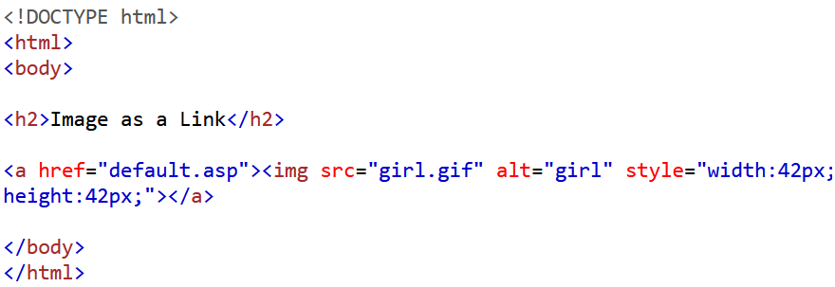

Figure-4.9: HTML example of image as a link

**Link to an Email Address:**

To create a link that launches the user's email client and allows them to send a new email, use the mailto: attribute within the href attribute:

Figure-4.10: A sample example of link to an Email Address

|  |  |
| --- | --- |
| ***4.5*** | ***TYPES OF HYPERLINKS IN HTML*** |

In HTML, there are two different kinds of hyperlinks: internal and external.

**Internal Links:**

Internal links are clickable links that take website visitors to specific web pages. Internal links connect pages that are part of the same domain.

Website navigation is one illustration.

Good internal connection has the following advantages:

* Internal links with anchor text increase usability.
* PageRank is enhanced by internal links.
* Internal link for the boat page.
* Links inside websites lower bounce rates.
* Internal links help your site be indexed better.

**External Links:**

External links are made to encourage visitors to click on a link that takes them away from your website. Outbound links, also known as external links, are crucial for search engine optimization.

External links include things like example.com, someplace.com, etc.

The advantages of effective external linkages are:

* Readers can benefit from external connections.
* Strong external links increase the authority of your website.
* Page ranking is unaffected by external links.
* Including external links is the same as offering more reading material.
* Links to external websites boost credibility.

**Example**

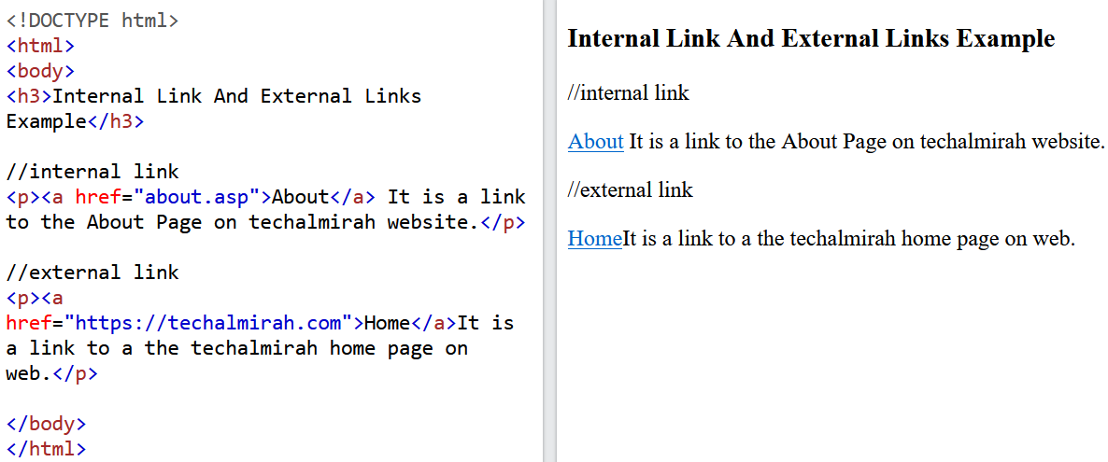  
Figure-4.11: An sample example of Internal and External Links

|  |  |
| --- | --- |
| ***4.6*** | ***POINTS TO REMEMBER*** |

* Hyper Text Markup Language, or HTML, is a markup language used to create web pages.
* HTML explains how a web page is organised and is composed of a number of parts.
* HTML - Elements label material, such as "This is a header," "This is a paragraph," or "This is a link," and instruct the browser how to display the content.
* A hyperlink, also known as a link or web link, refers to data that includes a destination's URL.
* Internal and external hyperlinks are two different sorts.

|  |  |
| --- | --- |
| ***4.7*** | ***GLOSSARY*** |

* HTML- Hypertext Markup Language.
* WWW - World Wide Web.
* <a> - Anchor tag
* <img> - Image tag
* <p> - Paragraph tag
* <head> - Head tag
* <body> - Body tag
* alt - Alternative
* <h3> - Heading tag
* href - Hypertext REFerence

|  |  |
| --- | --- |
| ***4.8*** | ***CHECK YOUR PROGRESS*** |

**Descriptive type questions-**

1. What exactly is HTML?
2. Describe how to use hyperlinks.
3. Describe the top five benefits of hyperlinks.
4. Briefly define hyperlinks.
5. What distinguishes an internal hyperlink from an external hyperlink?

**Objective type questions-**

1. HTML is an acronym for-
   1. HighText Machine Language
   2. HyperText and links Markup Language
   3. HyperText Markup Language
   4. None of these

1. The biggest heading in HTML is inserted using which of the following tag?

A. <h3>

B. <h1>

C. <h5>

D. <h6>

1. Which of the following tags is used in HTML to add a line break?

A. <br>

B. <a>

C. <pre>

D. <b>

1. In which of the following tags is a line break inserted in HTML?

A. <br>

B. <a>

C. <pre>

D. <b>

1. Which of the following tags in HTML is used to add a line break?

A. <br>

B. <a>

C. <pre>

D. <b>

1. How to create a hyperlink in HTML?
   1. <a href = "www.techalmirah.com"> techalmirah.com </a>
   2. <a url = "www.techalmirah.com" techalmirah.com /a>
   3. <a link = "www.techalmirah.com"> techalmirah.com </a>
   4. <a> www.techalmirah.com <techalmirah.com /a>
2. How do I make an ordered list in HTML (a list where the elements are numbered)?

A. <ul>

B. <ol>

C. <li>

D. I

1. Which of the following elements causes the text in HTML to be italicised?

A. <i>

B. <italic>

C. <it>

D. <pre>

1. How may an image be inserted into HTML?
   1. <img href = "jtp.png" />
   2. <img url = "jtp.png" />
   3. <img link = "jtp.png" />
   4. <img src = "jtp.png" />
2. How can a background colour be added to HTML?
   1. <marquee bg color: "red">
   2. <marquee bg-color = "red">
   3. <marquee bgcolor = "red">
   4. <marquee color = "red">
3. <input> is -
   1. a format tag.
   2. an empty tag.
   3. All of the above
   4. None of the above
4. Which of the following tags does the underlined text use?

A. I

B. <ul>

C. <u>

D. <pre>

1. What is the HTML code for a checkbox?
   1. <input type = "checkbox">
   2. <input type = "button">
   3. <checkbox>
   4. <input type = "check">
2. Which of the following tags is used to specify choices in a drop-down menu?
   1. <select>
   2. <list>
   3. <dropdown>
   4. <option>
3. HTML tags are surrounded by -
   1. # and #
   2. { and }
   3. ! and ?
   4. < and >
4. Which of the subsequent tags is utilised to add rows to the table?
   1. <td> and </td>
   2. <th> and </th>
   3. <tr> and </tr>
   4. None of the above
5. The HTML <hr> element is used for the following purposes-
   1. new line
   2. vertical ruler
   3. new paragraph
   4. horizontal ruler
6. Which of the following attributes is used to give an element a unique name?
   1. class
   2. id
   3. type
   4. None of the above
7. In order to show text with a scrolling effect, which of the following HTML tags is used?
   1. <marquee>
   2. <scroll>
   3. <div>
   4. None of the above
8. The special formatting element in HTML is (t) which of the following?
   1. <p>
   2. <b>
   3. <pre>
   4. None of the above
9. Which of the following is the proper method for sending HTML mail?
   1. <a href = "mailto: xy@y">
   2. <a href = "xy@y">
   3. <mail xy@y</mail>
   4. None of the above
10. Which of the following is the container for <tr>, <th>, and <td> ?
    1. <data>
    2. <table>
    3. <group>
    4. All the above
11. Including a background picture into HTML?
    1. <body background = "img.png">
    2. <img background = "img.png">
    3. <bg-image = "img.png">
    4. None of the above

**Answer (objective type question)-**

1. C
2. B
3. A
4. A
5. C
6. A
7. B
8. A
9. D
10. C
11. B
12. C
13. A
14. D
15. D
16. C
17. D
18. B
19. A
20. C
21. A
22. B
23. A

|  |  |
| --- | --- |
| ***4.9*** | ***BIBLIOGRAPHY/ REFERENCES*** |

* Musciano, C., & Kennedy, B. (2002). HTML & XHTML: The Definitive Guide: The Definitive Guide. " O'Reilly Media, Inc.".
* Duckett, J. (2011). *HTML & CSS: design and build websites* (Vol. 15). Indianapolis, IN: Wiley.
* Goossens, M., Rahtz, S. P., Rahtz, S., Gurari, E. M., Moore, R., & Sutor, R. S. (1999). *The LaTeX Web Companion: Integrating TeX, HTML, and XML* (Vol. 4). Addison-Wesley Professional.
* Castro, E. (2003). HTML for the world wide web. Peachpit Press.

* Goodman, D. (2002). Dynamic HTML: The definitive reference: A comprehensive resource for HTML, CSS, DOM & JavaScript. " O'Reilly Media, Inc.".
* Raggett, D., Lam, J., Alexander, I., & Kmiec, M. (1998). Raggett on HTML 4. Addison-Wesley Longman Publishing Co., Inc..
* Robbins, J. N. (2012). Learning web design: A beginner's guide to HTML, CSS, JavaScript, and web graphics. " O'Reilly Media, Inc.".

* <https://www.w3schools.com/>
* <https://www.geeksforgeeks.org/>

|  |  |
| --- | --- |
| ***4.10*** | ***SUGGESTED READINGS*** |

* Musciano, C., & Kennedy, B. (2002). HTML & XHTML: The Definitive Guide: The Definitive Guide. " O'Reilly Media, Inc.".
* Goodman, D. (2002). Dynamic HTML: The definitive reference: A comprehensive resource for HTML, CSS, DOM & JavaScript. " O'Reilly Media, Inc.".
* <https://www.w3schools.com/>